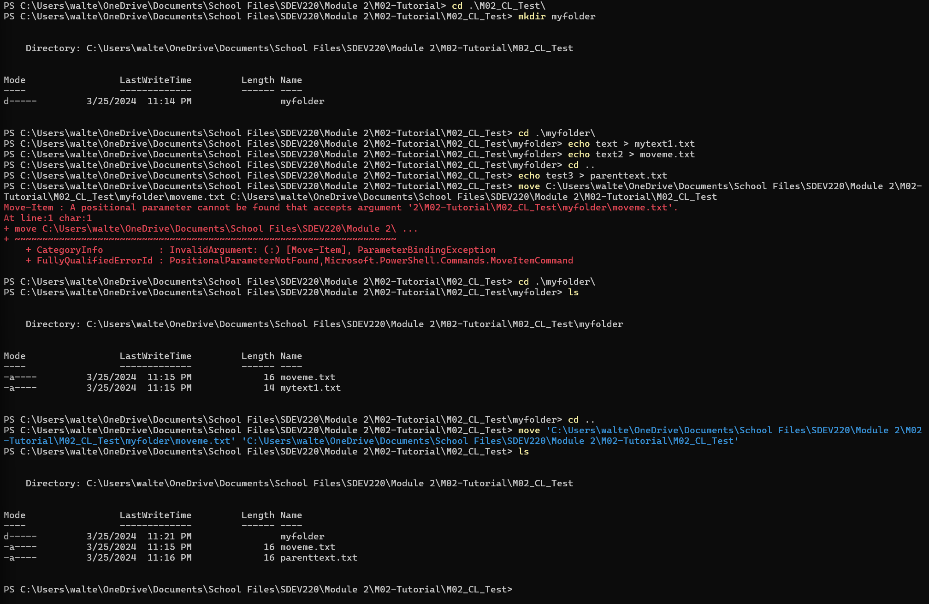

Had an error come up, but I saw my mistake.